**Steps to fallow to build the legacy report to power bi report**

Step 1 :- Data team will provide column mapping doc, find your respective report

Here it is New_MG4_Report_Column_Mapping_Document

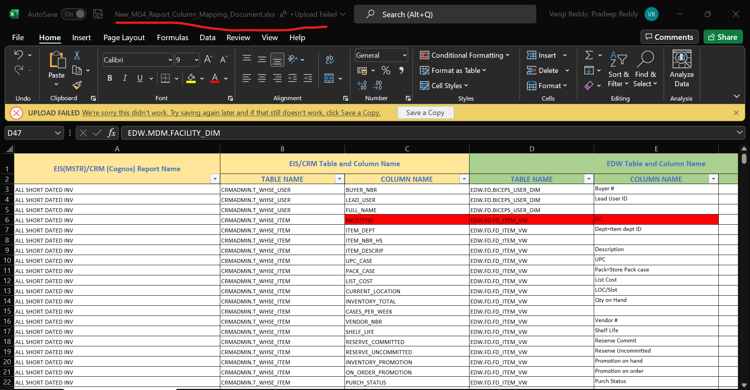

Step 2 :- Find out respective report assigned to you Here I am filtering Allocation Report.

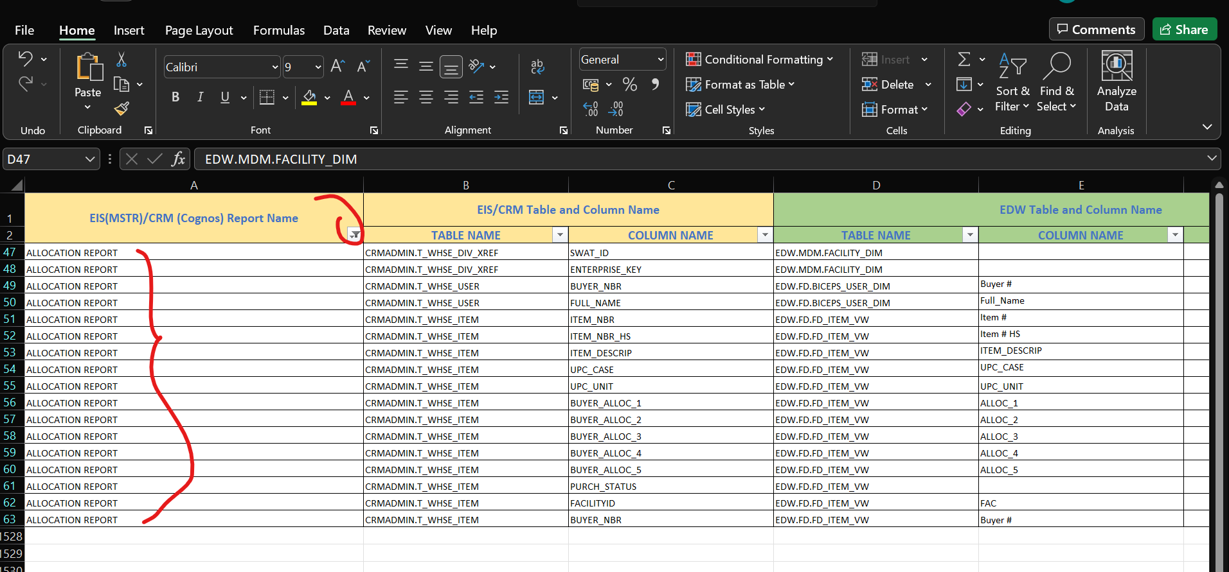

Step 3 :- Find out the path of that respective report in MSTR or Cognos and also check whether it is a Cognos are MSTR report here allocation report is Cognos

Here the file name is (file MG4 feedback executive).

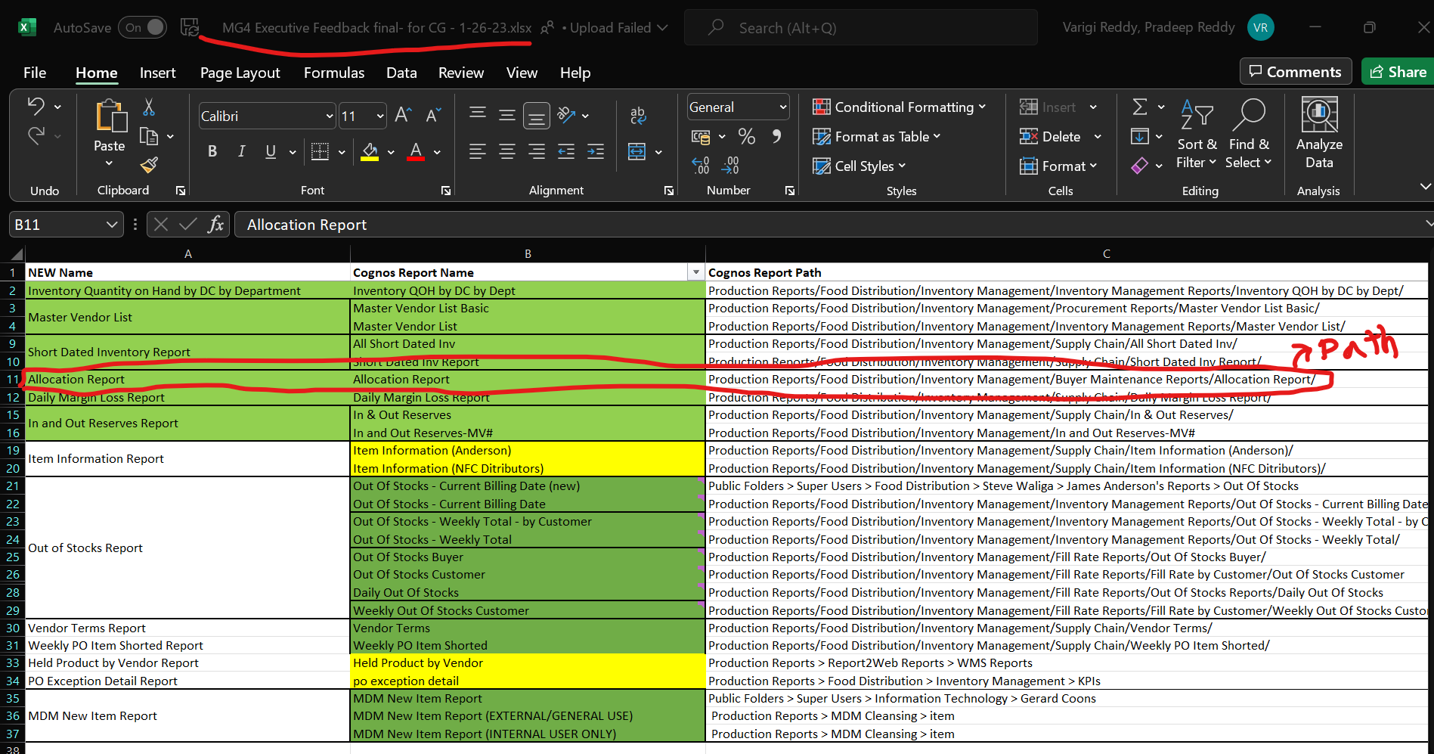

Go Cognos and fallow the path

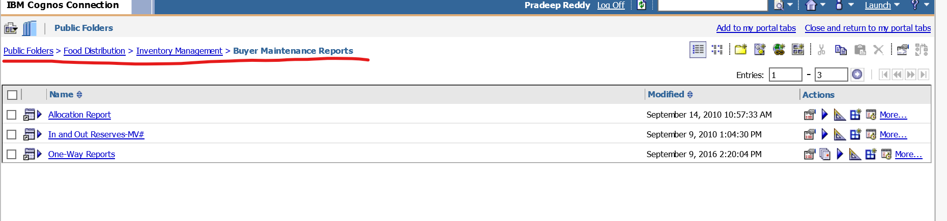

Step 4: Once we found the report click on run report to check the what filters they applied click on the run button here I am selecting allocation report

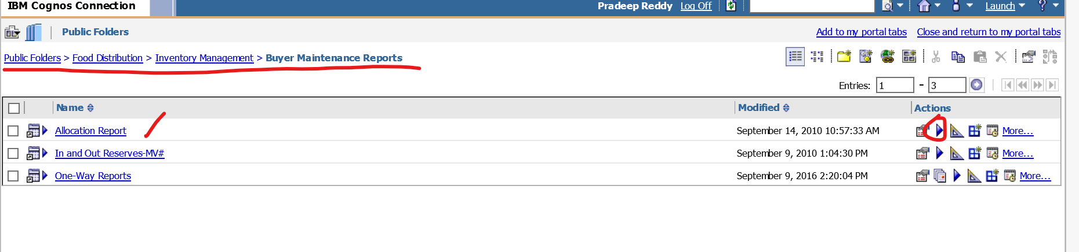

Don’t select anything click on run

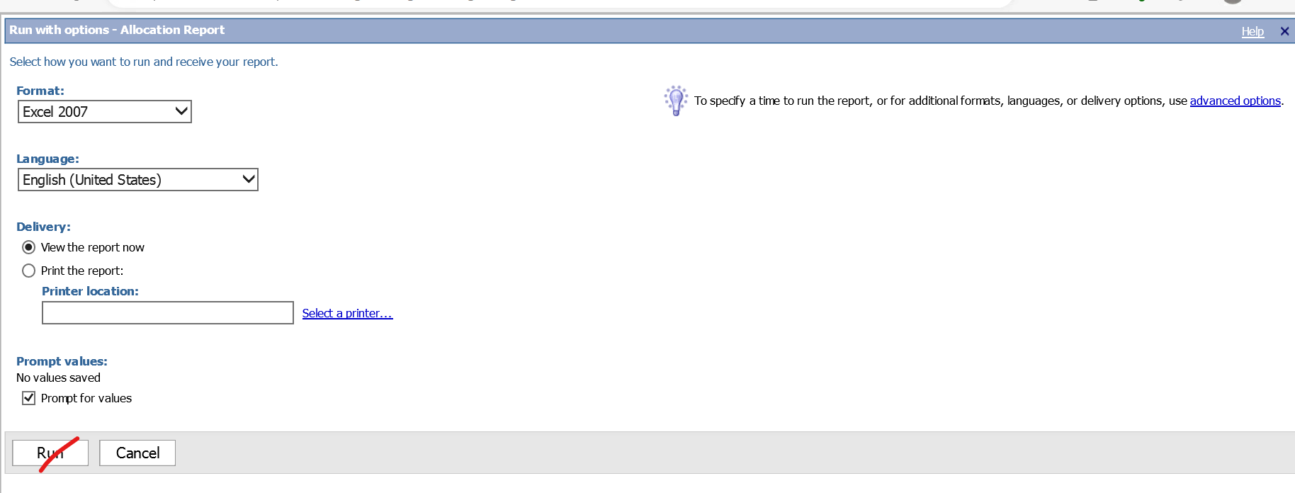

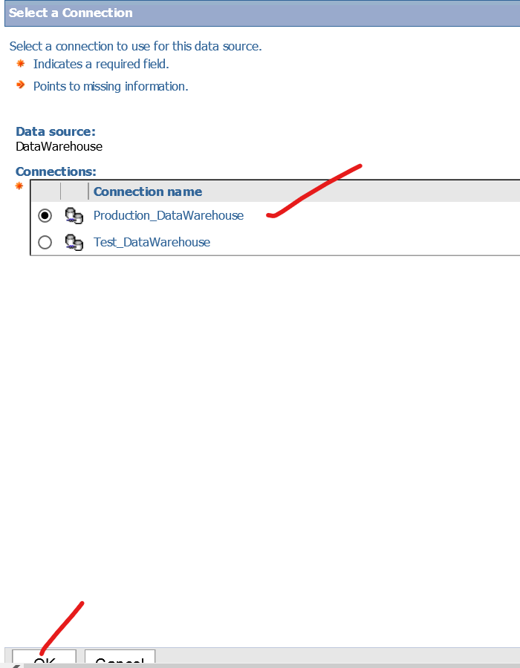

Then you are able to see what filter you need create in your report here we have only one filter which is buyer no if have any we will get next button is enabled.

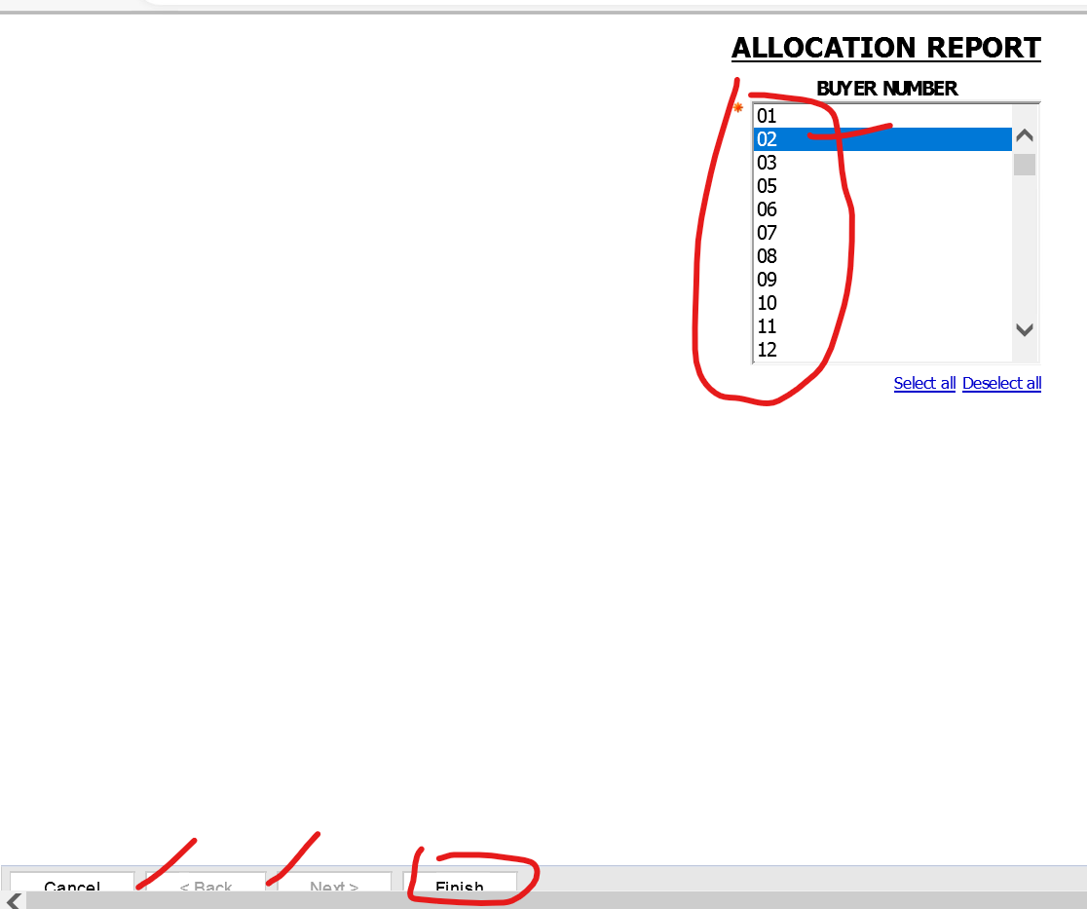

Once u click on the finish excel sheet will be downloaded

Where u can see all columns for this respective report.

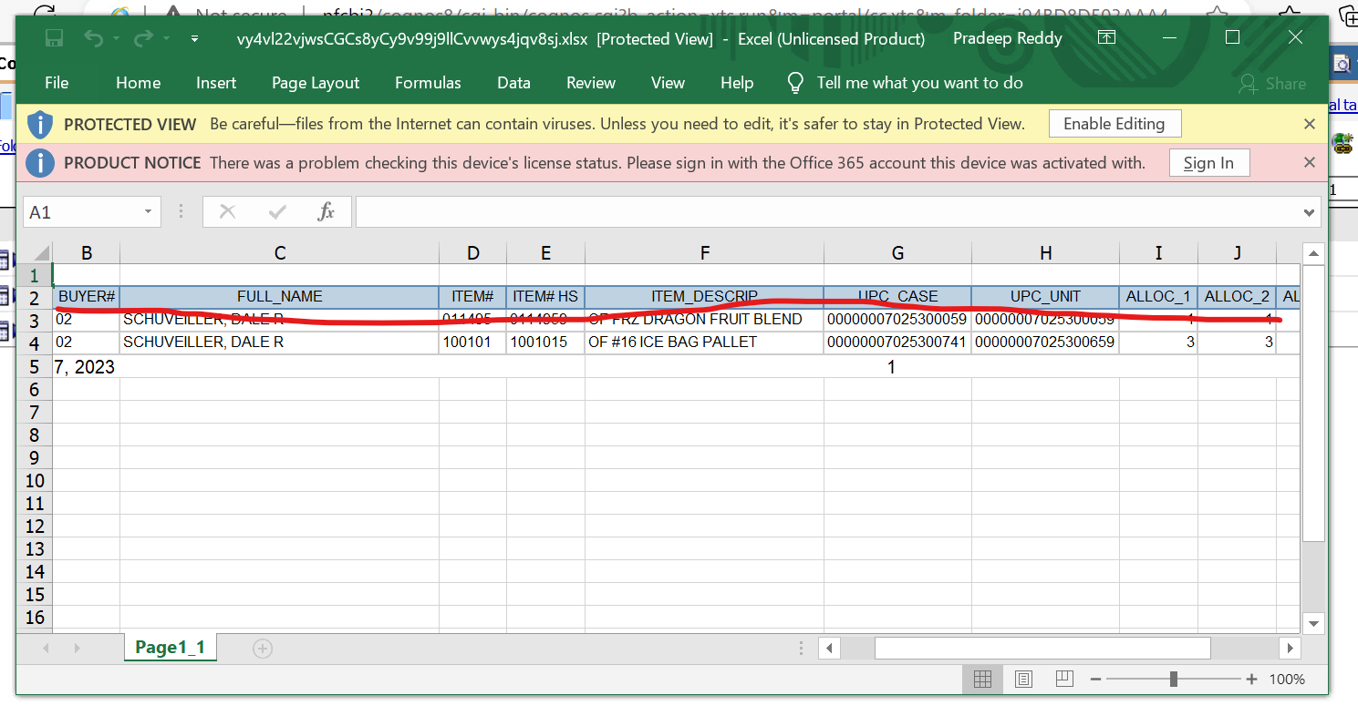

Step 5 : Open the report studio check the measures they have used. To check the measures in cognos open the query tool click on the query 1 it will show all the columns it has and storm symbol on the column refer to measure.

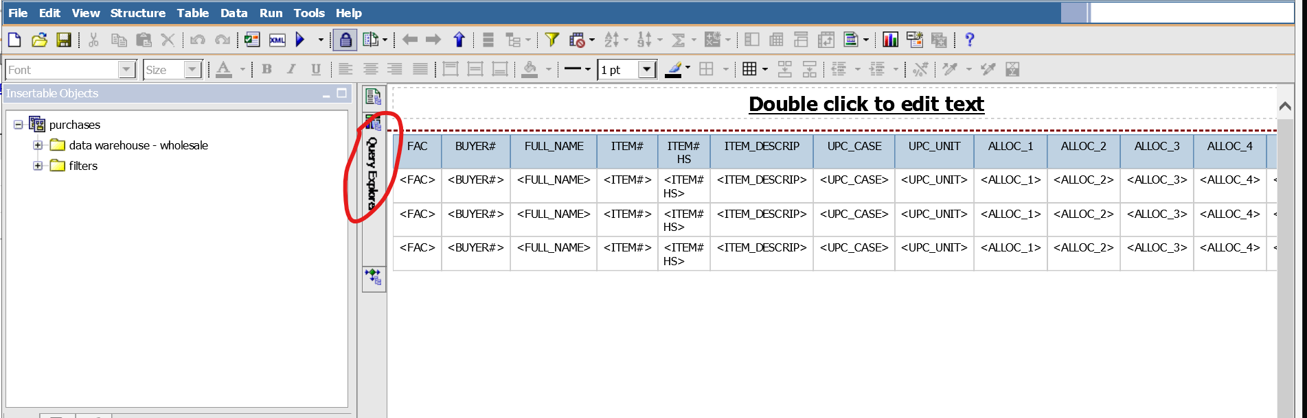

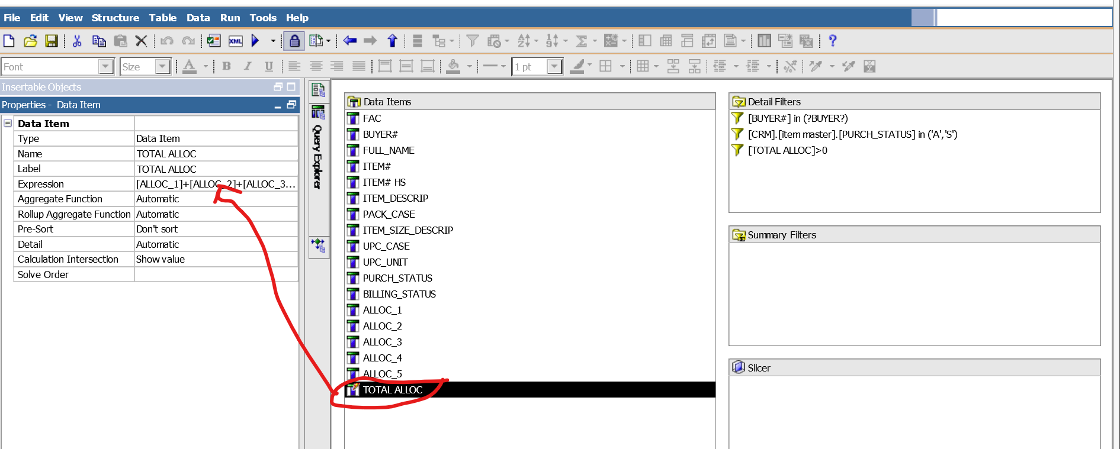

To check measures in MSTR Yellow Icon indicates the measure (only for checking measures don’t select any filter just click on next …. and finish (MSTR)) right click on the yellow icon and edit.

Then u see the formula to create a measure.

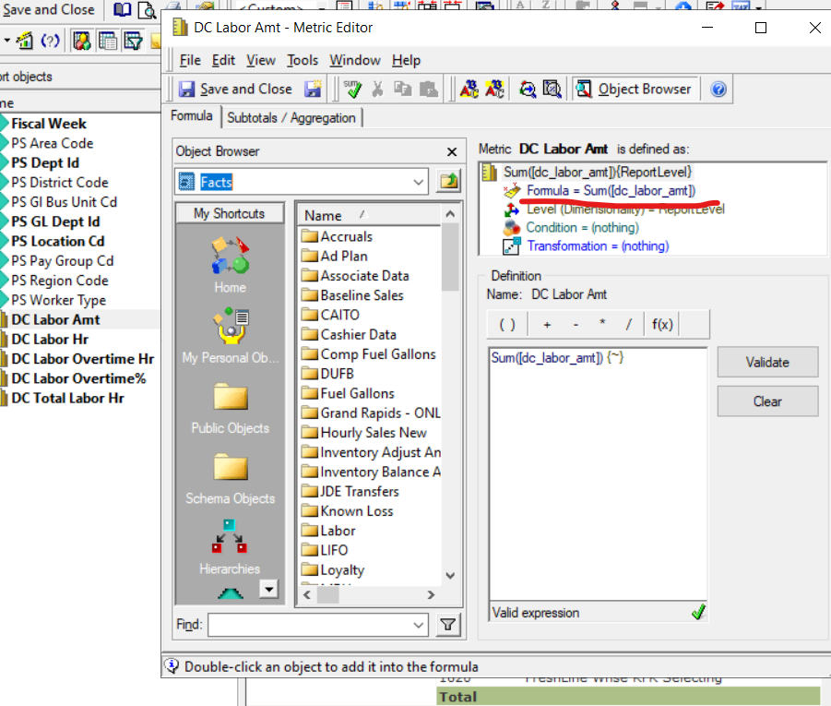

Step 5 :- Extract the SQL query MSTR or Cognos, so that you come to know filters , columns, table names, and database by using this able to build the power bi reports.

Path to SQL query in Cognos Tool> show generated SQL/mdx

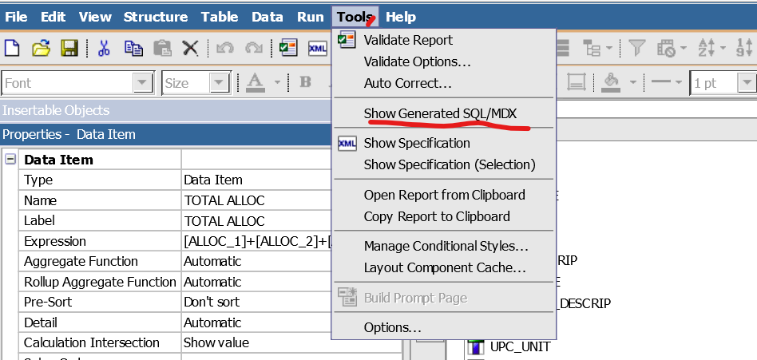

Buyer 1 refers to filter condition

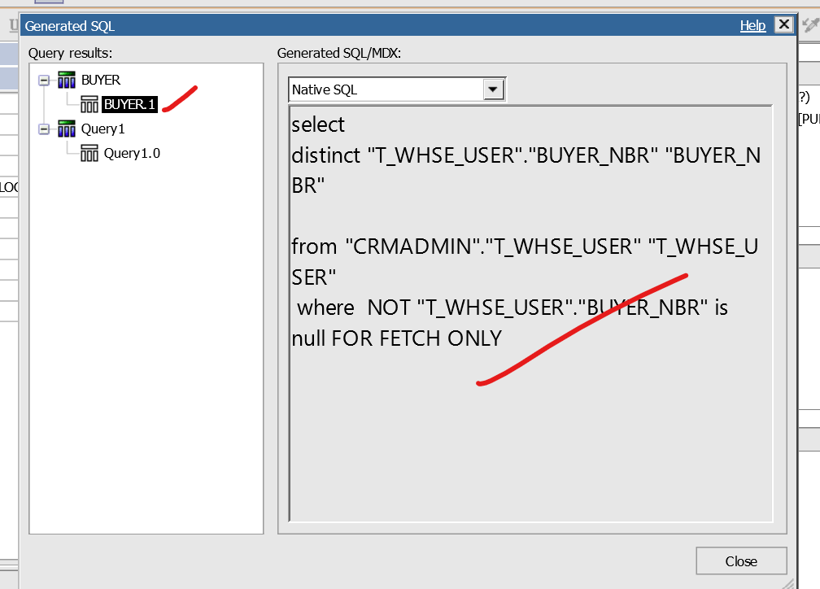

Path to MSTR :View>Show QL

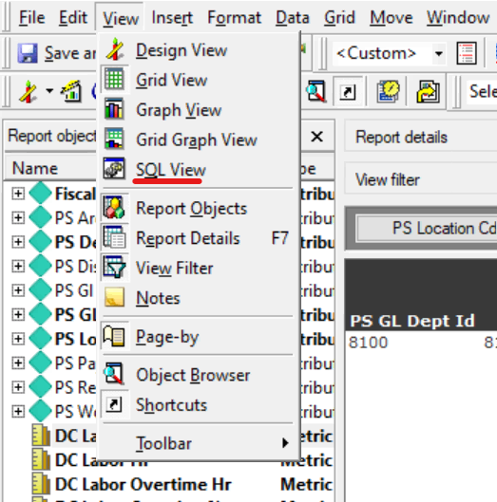

Query 1 refers to entire reports

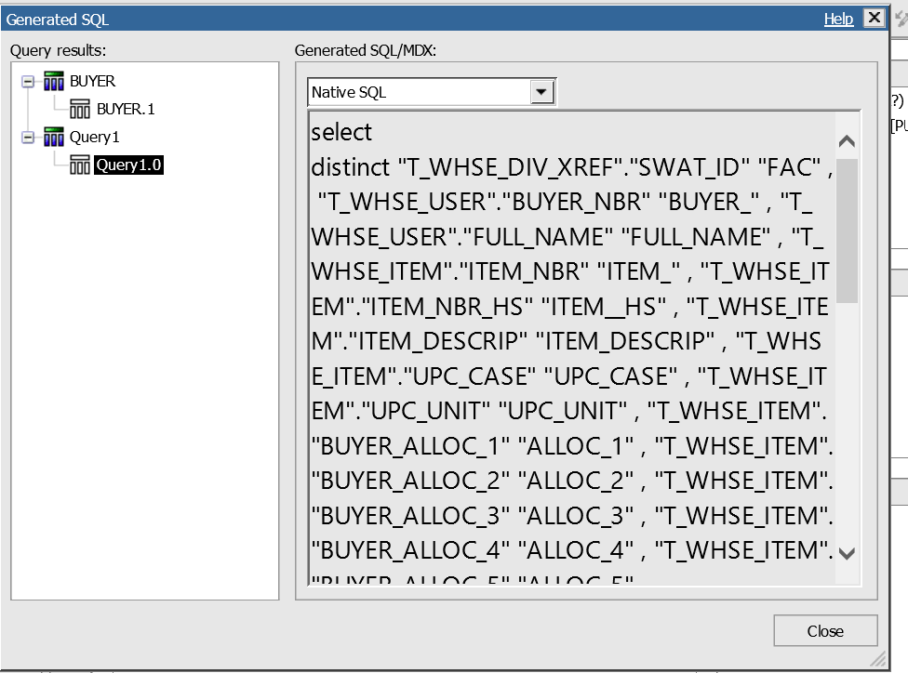

Copy and paste the quey and arrange in a order to understand the query.

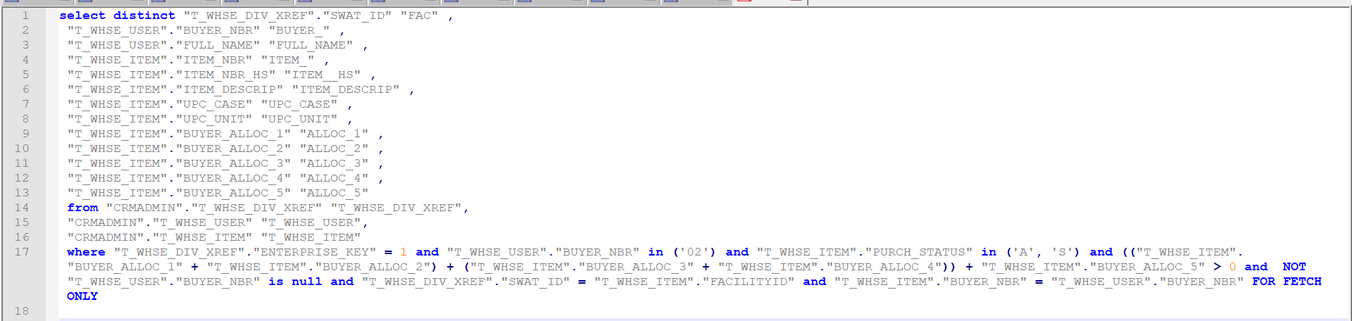

Step 6 : once we found the column mapping from legacy report, next we need find the new column names and tables names form snowflakes and identify the respective tables w.r.to the report you are going to build.

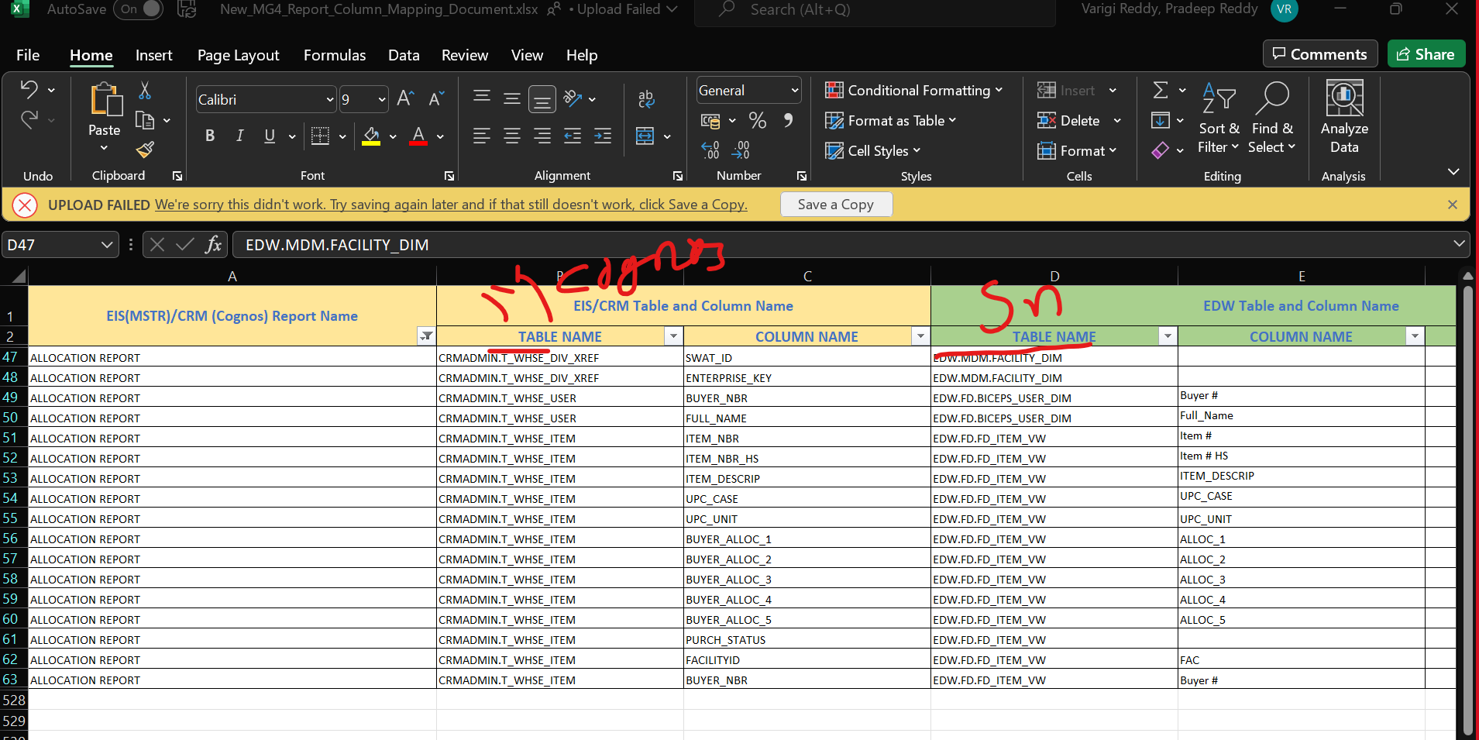

Step 8 :- Building the report,

Note : Here we are maintaining the data model in pbix format, In this we cannot able to edit any relationships, columns, we simple need to import it and build the report accordingly.

So if want to create any measures are transformation are relationship we need to check with team and add it on the pbix file and publish it so that every will able to access that.

Getdata-> PowerBIDatasets

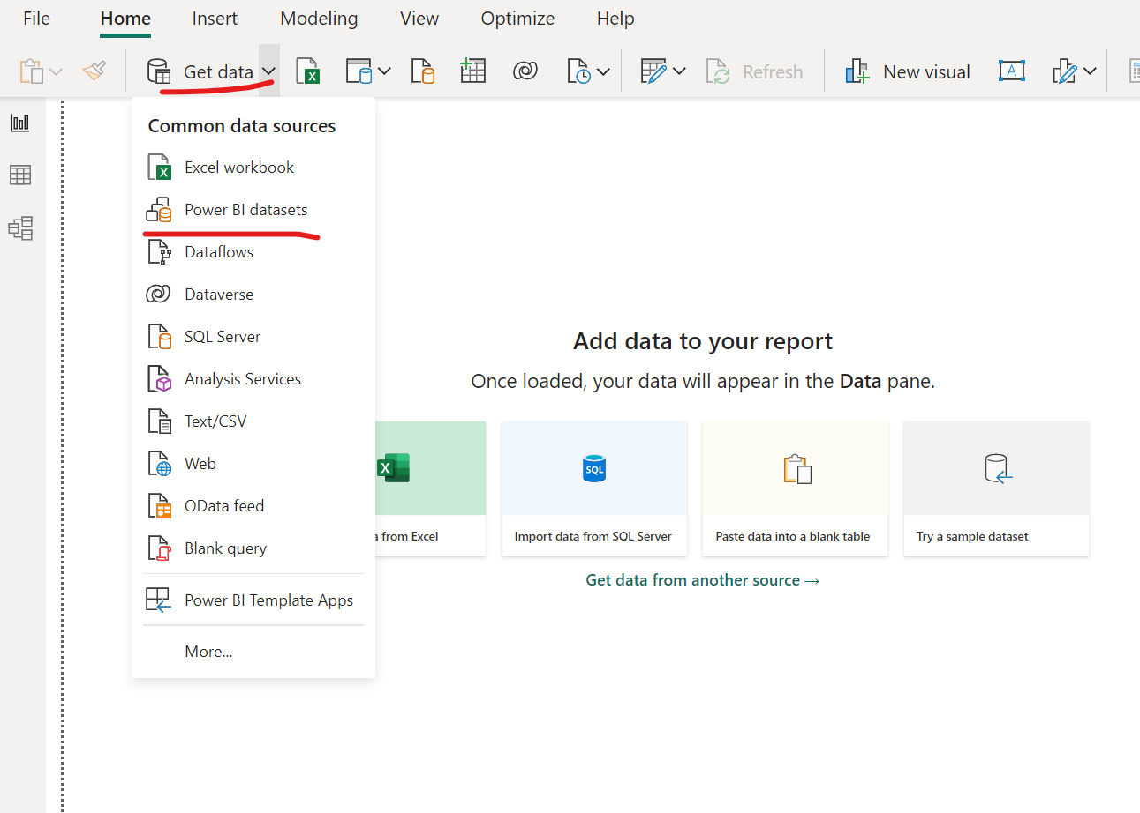

After selecting this new window will open select your data model here I am selecting the retails data model.

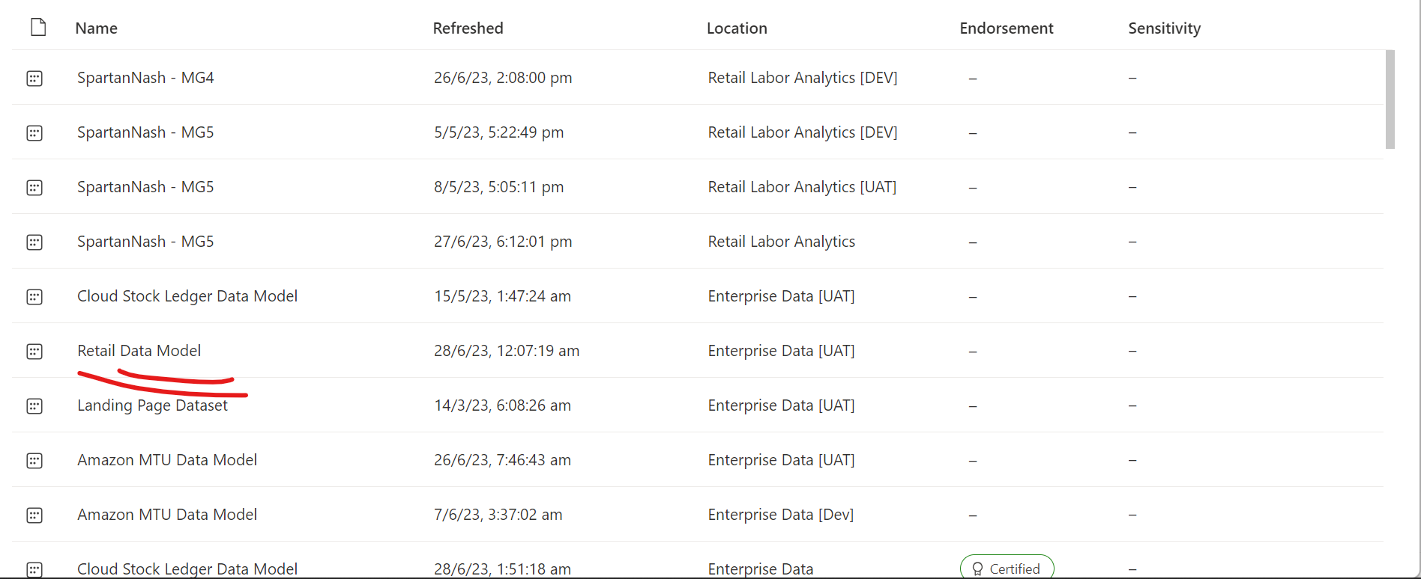

Once you selected the your data model all the data will appear on data pan

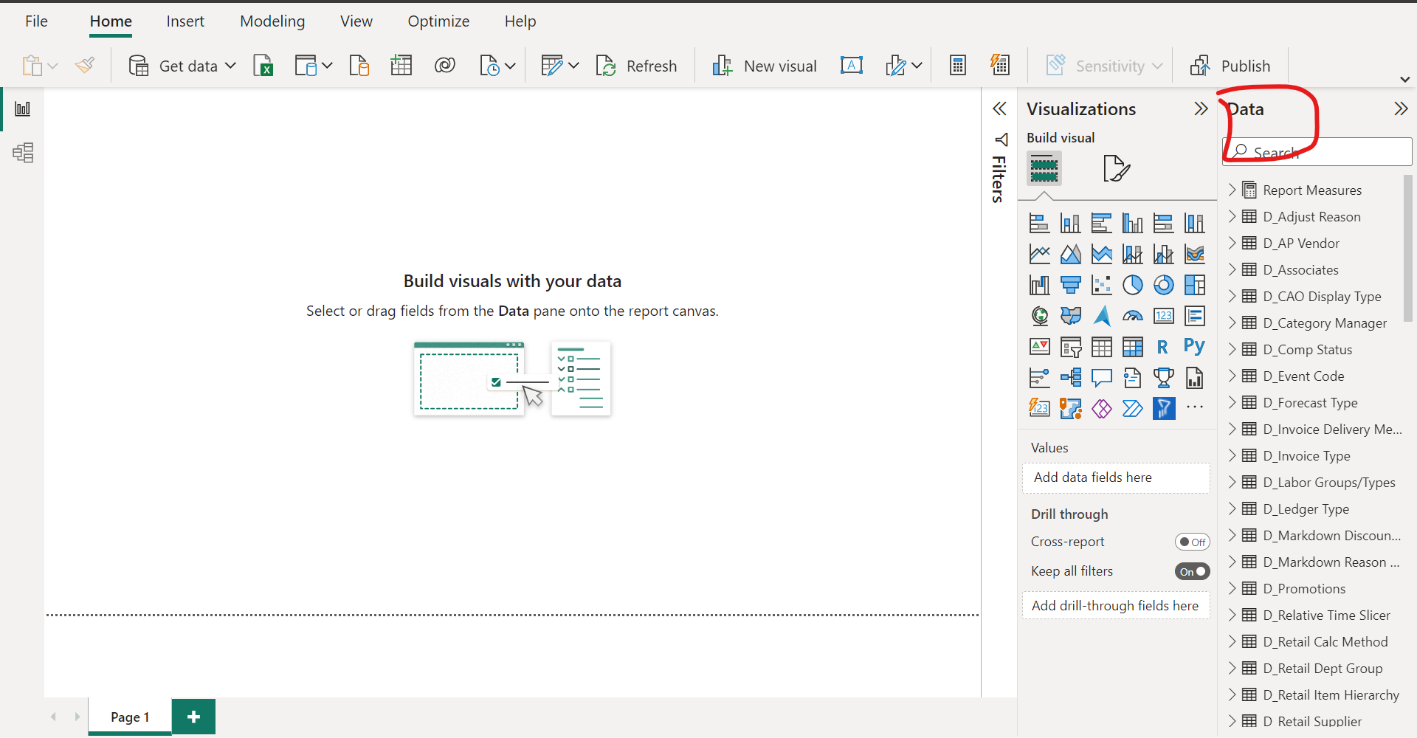

Step 9:- In this phase we need to identify the table , for that we need create new excel sheet. With your report name. Here u need to mention all your legacy and snowflakes table name and column names.

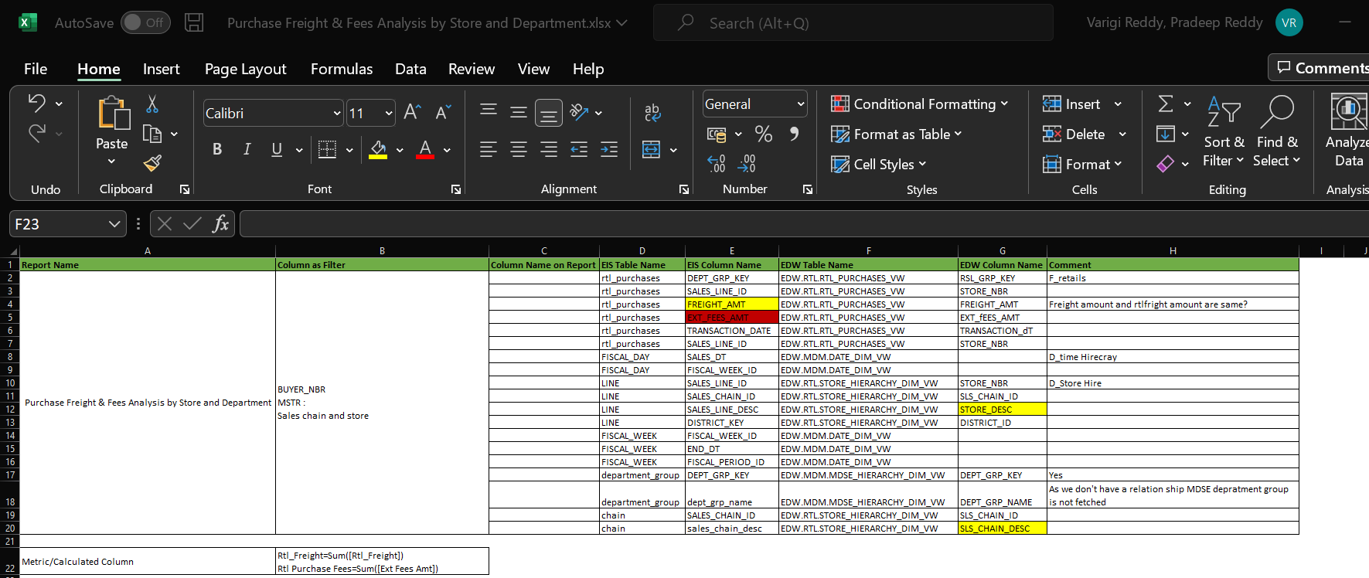

Step 10 :- After identifying your tables simply drag and drop your tables in to model view.

Here u no need create any relation ship data model team is already created every thing u simple drag and drop.

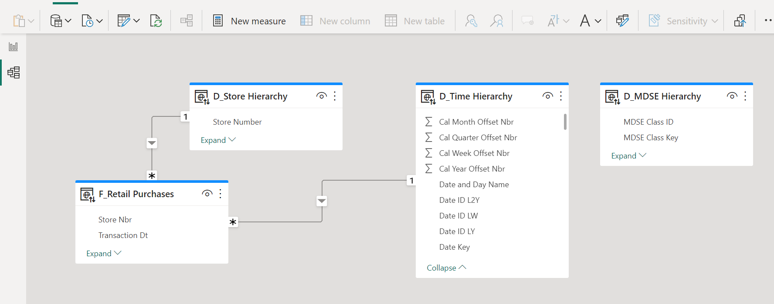

Step 11: In the next phase u need to check the filter they have applied for that u need to go MSTR and fallow the path of that report. Discussed in step 3

<http://grmdssweb01/eis/WelcomePage/Welcome.php>

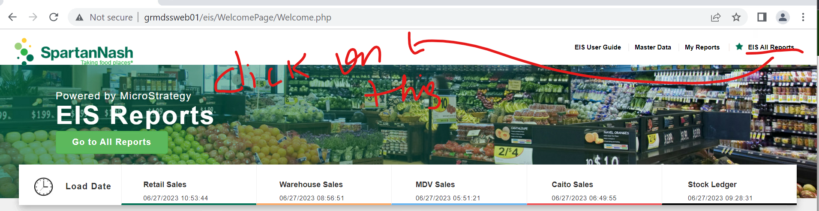

Click on this and fallow the path you get a filters applied on the report same filter u need to create on the power by.

Time Period

Relative Time

Note : time is already created in data model

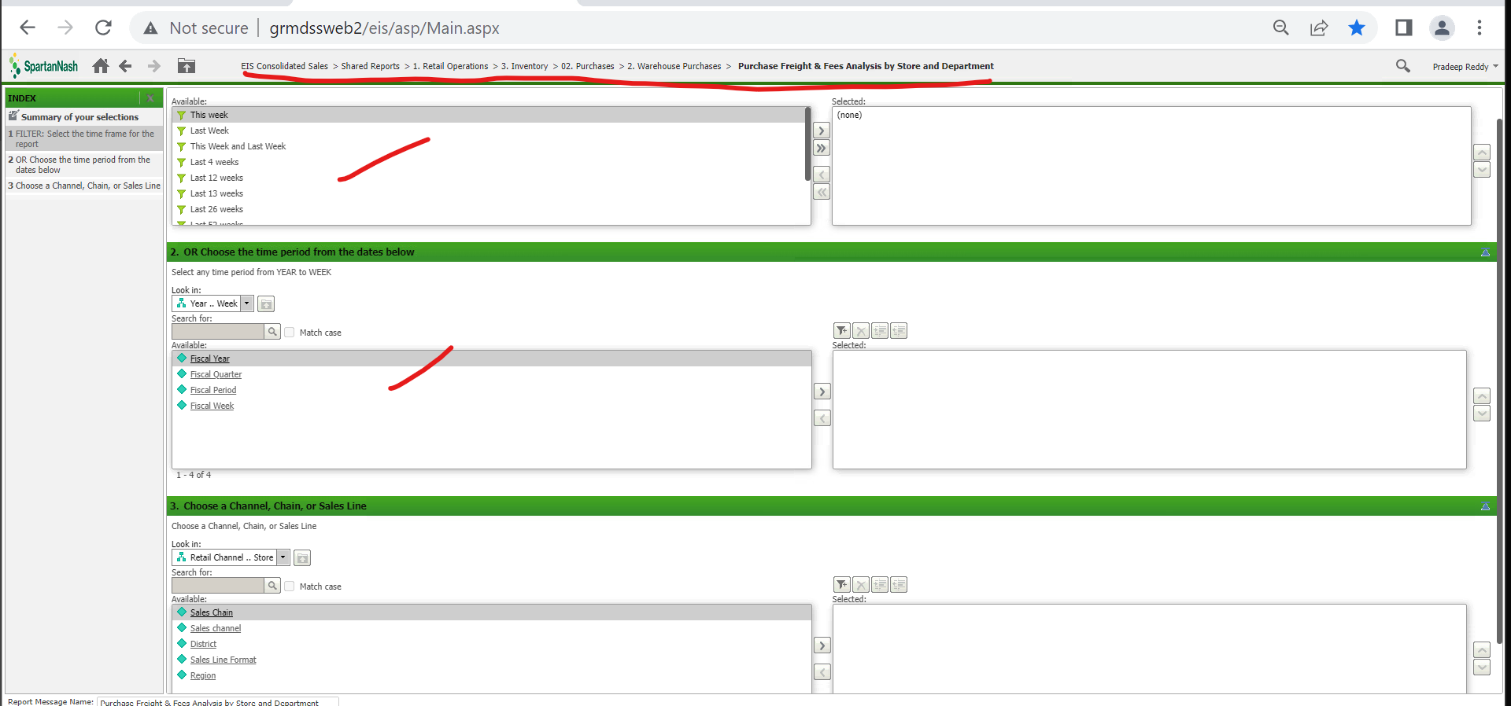

Lets create this filters on the report.

Note : Same columns will be available in many table , make sure you identify the column in right table.

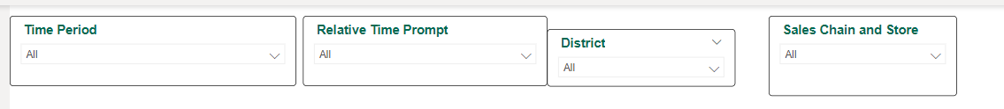

Step 12 :- In this step u need to build the report and DAX or matrix columns they have used for that go to micro strategy service which is desktop app.

Here also you need to fallow the path to identify the report.

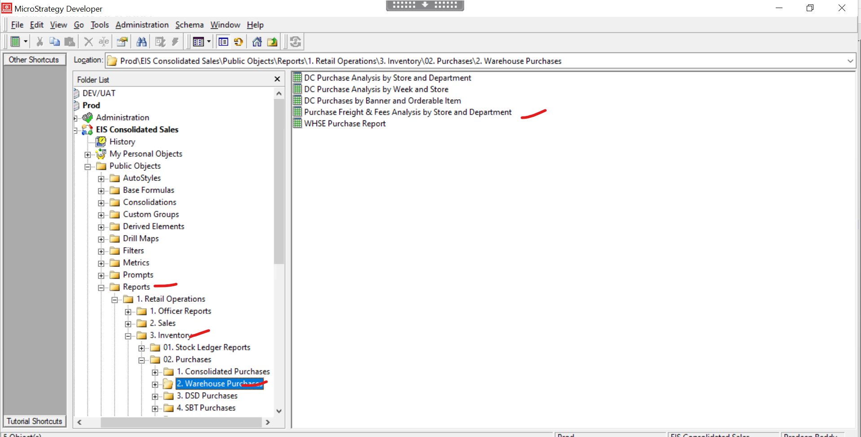

Click on the report no need to select any filter click next…. And finish then your able see the report.

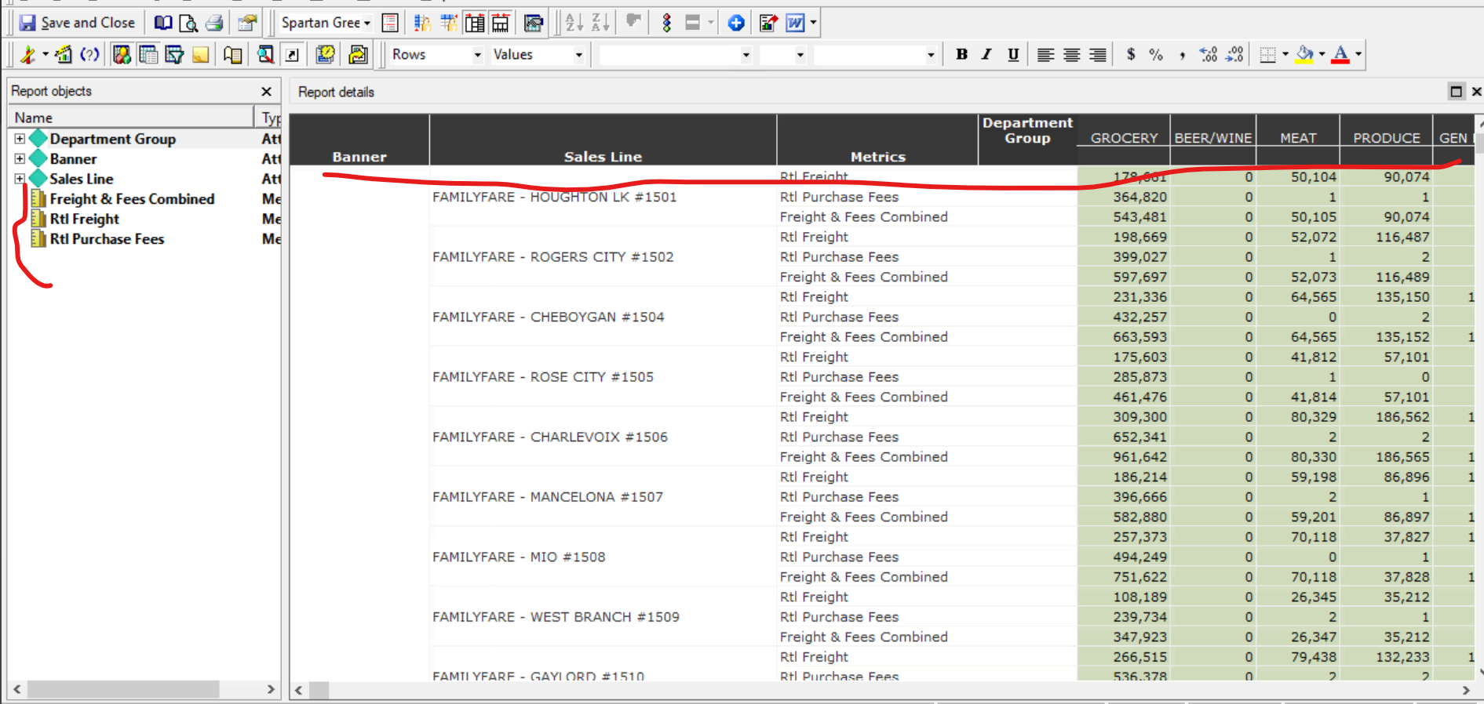

Right click on yellow scale and click on edit then are able to see the formula they have used.

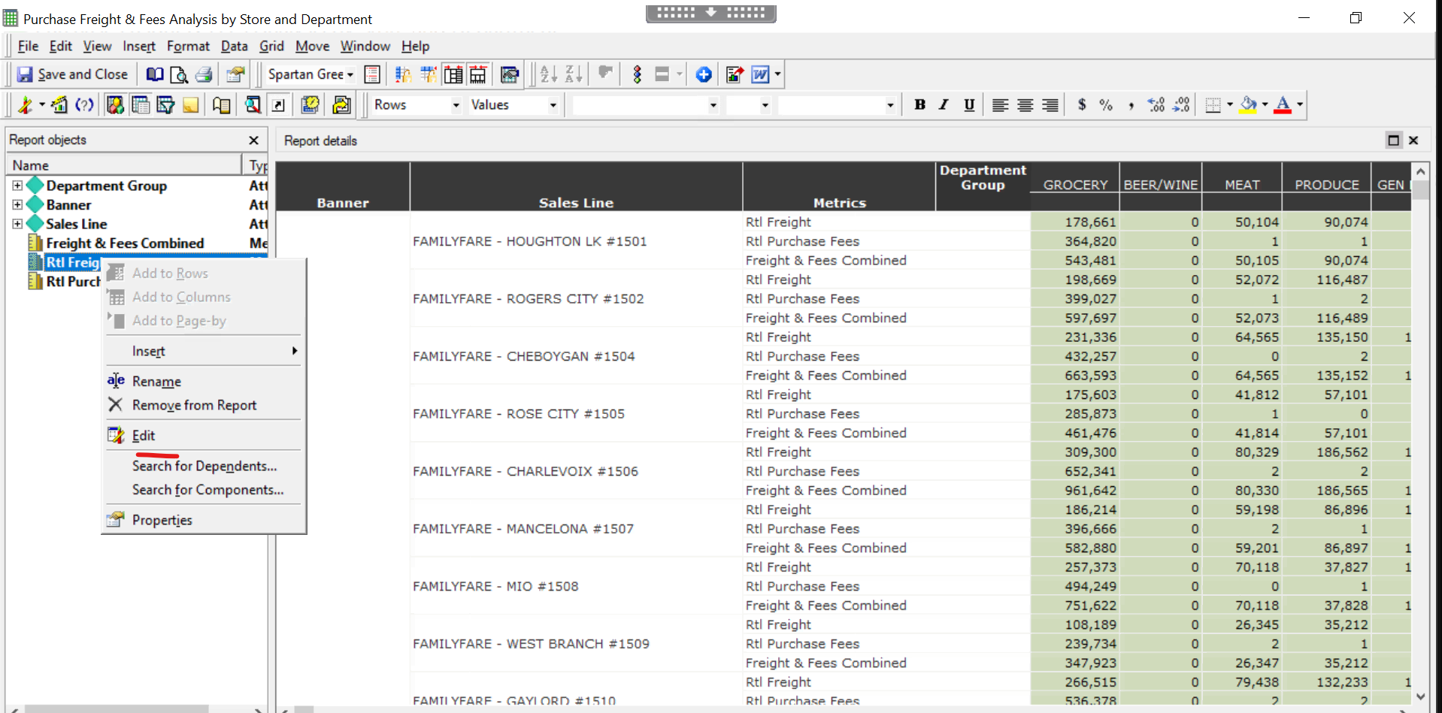

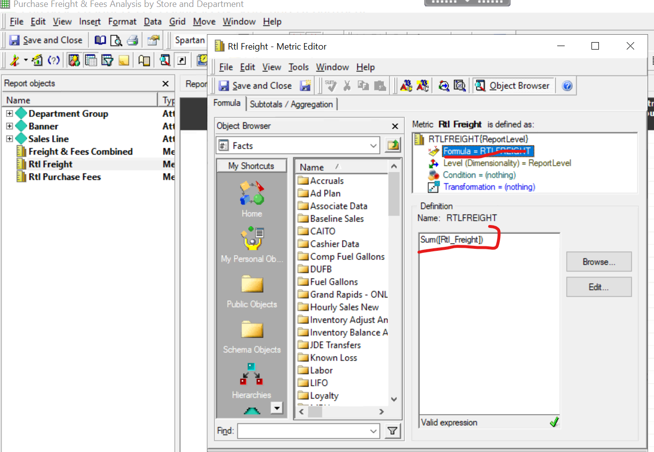

Here if u see yellow scale represent calculated formula which u want to create measure or DAX or metrics or calculated in the powerbi.

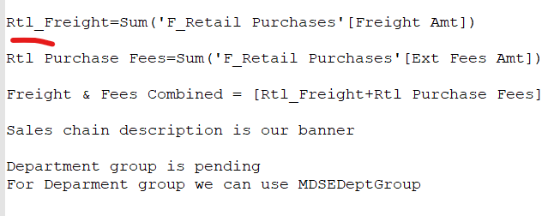

Step 13 :- After creating filter look at the legacy what columns they have used replacate the same in power bi.

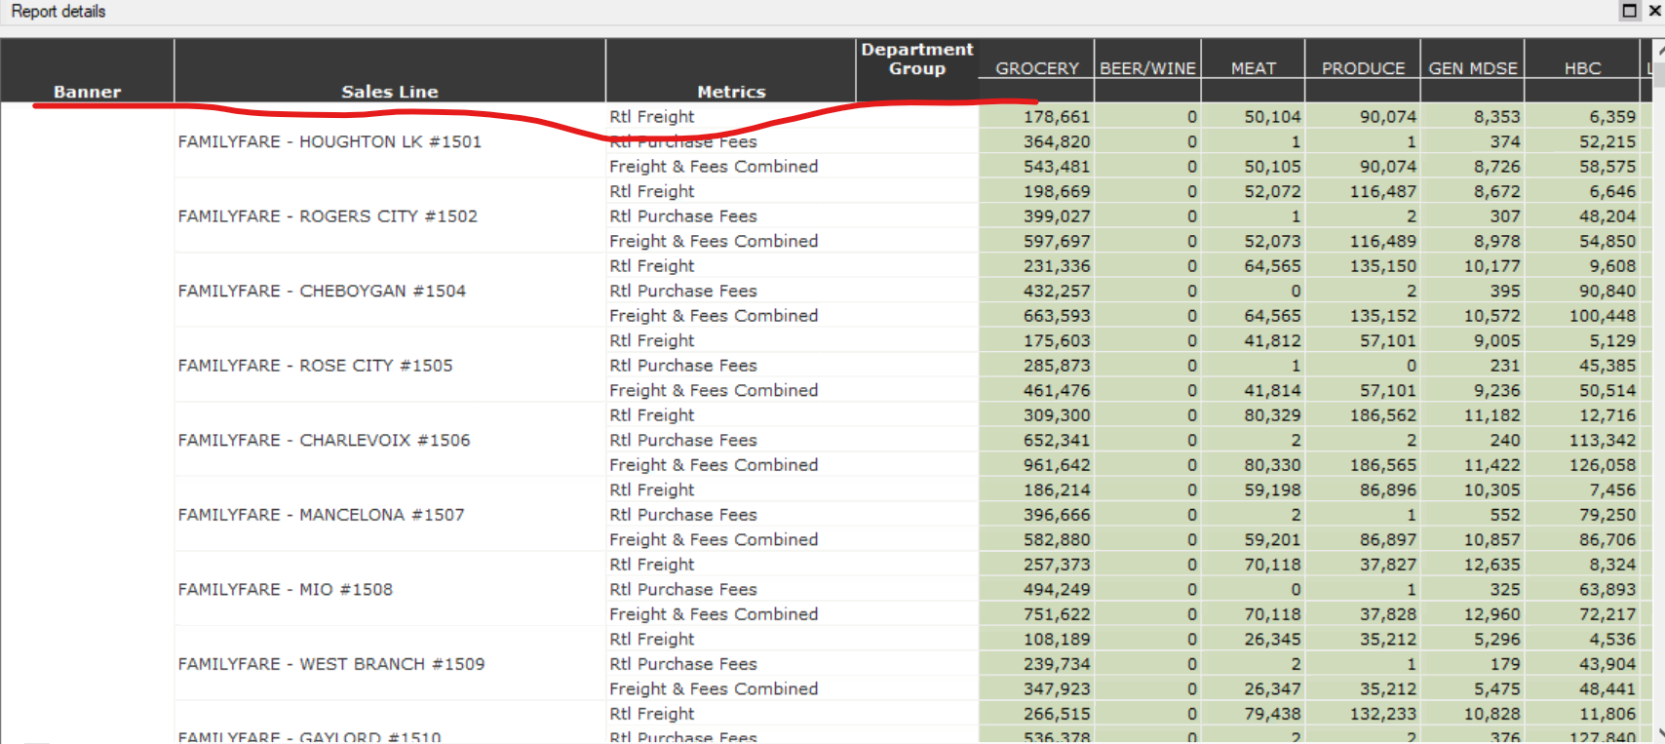

To build this report I have used matrix in power bi.

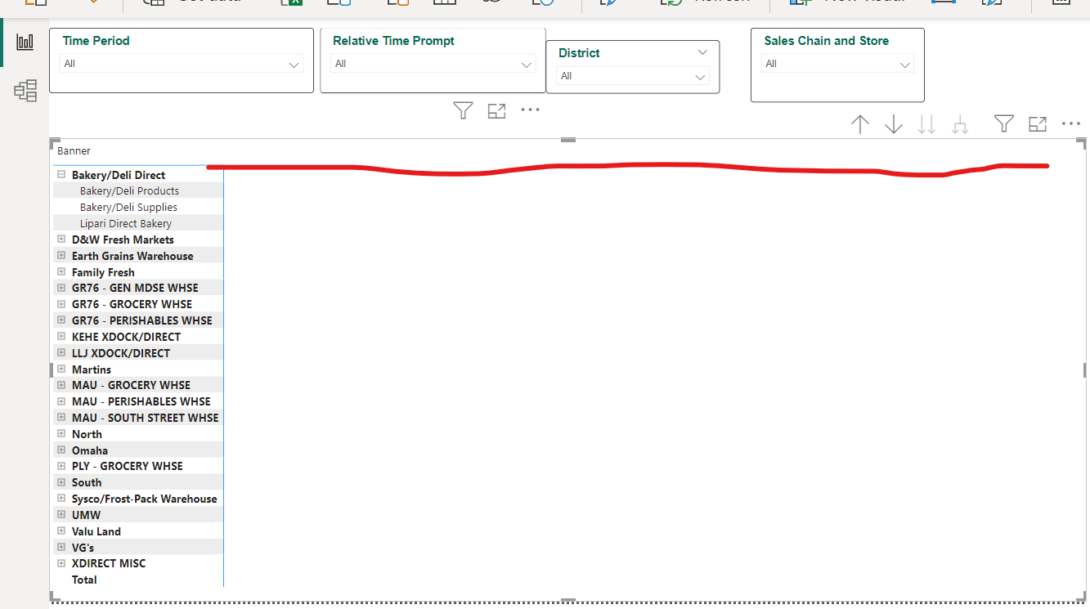

This report is in pending need to add columns and DAX to it